Coding Challenge 5: Data Wrangling
Your Name
2026-03-05

Load Libraries
library(tidyverse)

1. Read in the Data
diversity <- read.csv("../../Week 09/DiversityData.csv")
metadata <- read.csv("../../Week 09/Metadata.csv")

2. Join the Two Dataframes
joining diversity and metadata by Code column
alpha <- inner_join(diversity, metadata, by = "Code")

3. Calculate Pielou’s Evenness Index
evenness = shannon / log(richness)
alpha_even <- alpha %>%
mutate(even = shannon / log(richness))

4. Summarize by Crop and Time Point
alpha_average <- alpha_even %>%
group_by(Crop, Time_Point) %>%
summarise(
mean.even = mean(even, na.rm = TRUE),
n = n(),
sd.even = sd(even, na.rm = TRUE),
se.even = sd.even / sqrt(n)
)

5. Calculate Differences Between Crop and Soil
pivot to wide format then calculate differences between soil and cotton and soil and soybean
alpha_average2 <- alpha_average %>%
select(Time_Point, Crop, mean.even) %>%
pivot_wider(names_from = Crop, values_from = mean.even) %>%
mutate(diff.cotton.even = Soil - Cotton,
diff.soybean.even = Soil - Soybean)

6. Plot
alpha_average2 %>%
select(Time_Point, diff.cotton.even, diff.soybean.even) %>%
pivot_longer(c(diff.cotton.even, diff.soybean.even), names_to = "diff") %>%
ggplot(aes(x = Time_Point, y = value, color = diff)) +
geom_line() +
labs(x = "Time Point", y = "Difference in Evenness", color = "Comparison") +
theme_classic()
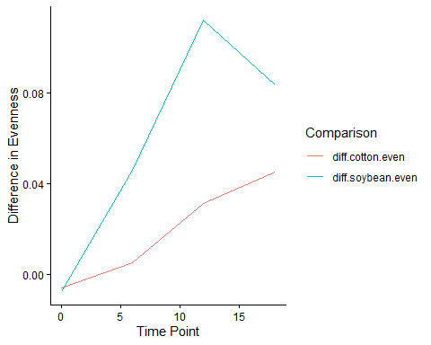

GitHub Link
Coding Challenge 5 on GitHub

